PROCEDURES

PROCEDURE 1 — ADD_TEAM_MEMBER
Purpose:
Adds a new team member into the TeamMembers table using IN parameters.
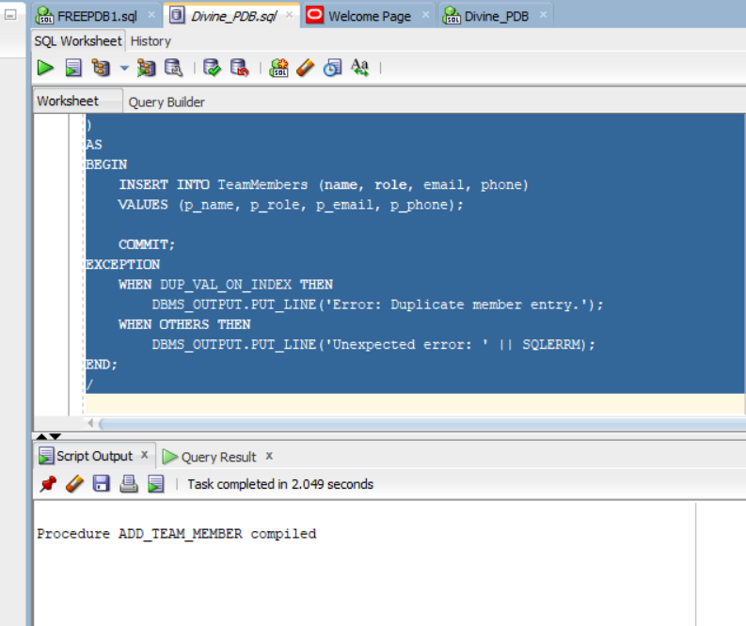

Codes:

CREATE OR REPLACE PROCEDURE add_team_member(
p_name IN VARCHAR2,
p_role IN VARCHAR2,
p_email IN VARCHAR2,
p_phone IN VARCHAR2
)
AS
BEGIN
INSERT INTO TeamMembers (name, role, email, phone)
VALUES (p_name, p_role, p_email, p_phone);

COMMIT;
EXCEPTION
WHEN DUP_VAL_ON_INDEX THEN
DBMS_OUTPUT.PUT_LINE('Error: Duplicate member entry.');
WHEN OTHERS THEN
DBMS_OUTPUT.PUT_LINE('Unexpected error: ' || SQLERRM);
END;
/

PROCEDURE 2 — UPDATE_PROJECT_STATUS
Purpose :
Updates the status of a project by ID.
Code:
CREATE OR REPLACE PROCEDURE update_project_status(
p_project_id IN NUMBER,
p_new_status IN VARCHAR2
)
AS
BEGIN
UPDATE Projects
SET status = p_new_status
WHERE project_id = p_project_id;

IF SQL%ROWCOUNT = 0 THEN
DBMS_OUTPUT.PUT_LINE('No project found with that ID.');
END IF;

COMMIT;
EXCEPTION
WHEN OTHERS THEN
DBMS_OUTPUT.PUT_LINE('Error updating project: ' || SQLERRM);
END;
/

PROCEDURE 3 — DELETE_DESIGN
Purpose:
Deletes a design record by ID.
Code:

CREATE OR REPLACE PROCEDURE delete_design(
p_design_id IN NUMBER
)
AS
BEGIN
DELETE FROM Designs
WHERE design_id = p_design_id;

IF SQL%ROWCOUNT = 0 THEN
DBMS_OUTPUT.PUT_LINE('No design found with that ID.');
END IF;

COMMIT;
EXCEPTION
WHEN OTHERS THEN
DBMS_OUTPUT.PUT_LINE('Error deleting design: ' || SQLERRM);
END;
/

PROCEDURE 4 — REGISTER_PAYMENT (with validation)
Purpose:
Registers a new payment for a project, ensuring project exists before inserting.
Code:

CREATE OR REPLACE PROCEDURE register_payment(
p_project_id IN NUMBER,
p_client_id IN NUMBER,
p_amount IN NUMBER
)
AS
v_exists NUMBER;
BEGIN
-- Validate project
SELECT COUNT(*) INTO v_exists
FROM Projects
WHERE project_id = p_project_id;

IF v_exists = 0 THEN
DBMS_OUTPUT.PUT_LINE('Invalid project: does not exist.');
RETURN;
END IF;

INSERT INTO Sales (project_id, client_id, amount, issued_date)
VALUES (p_project_id, p_client_id, p_amount, SYSDATE);

COMMIT;
EXCEPTION
WHEN OTHERS THEN
DBMS_OUTPUT.PUT_LINE('Error registering payment: ' || SQLERRM);
END;
/

PROCEDURE 5 — LIST_TEAM_MEMBERS_CURSOR (Explicit Cursor)
Purpose:
Uses an explicit cursor to loop through all team members and print names + roles.
Codes:
CREATE OR REPLACE PROCEDURE list_team_members_cursor
AS
-- Declare the cursor
CURSOR team_cursor IS
SELECT name, role FROM TeamMembers;

v_name TeamMembers.name%TYPE;
v_role TeamMembers.role%TYPE;
BEGIN
OPEN team_cursor;

LOOP
FETCH team_cursor INTO v_name, v_role;
EXIT WHEN team_cursor%NOTFOUND;

DBMS_OUTPUT.PUT_LINE('Name: ' || v_name || ' | Role: ' || v_role);
END LOOP;

CLOSE team_cursor;

EXCEPTION
WHEN OTHERS THEN
DBMS_OUTPUT.PUT_LINE('Cursor error: ' || SQLERRM);
END;
/

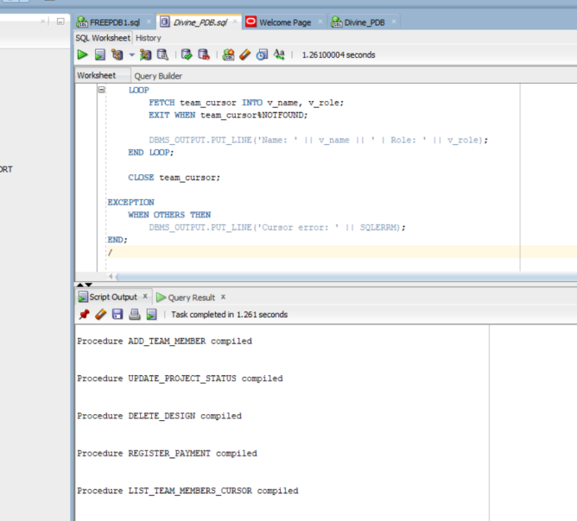

FUNCTIONS

FUNCTION 1 — GET_PROJECT_TOTAL_PAYMENTS
Purpose:
Returns the total amount of money paid for a given project.
Codes:
CREATE OR REPLACE FUNCTION get_project_total_payments(
p_project_id IN NUMBER
)
RETURN NUMBER
AS
v_total NUMBER;
BEGIN
SELECT NVL(SUM(amount), 0)
INTO v_total
FROM Sales
WHERE project_id = p_project_id;

RETURN v_total;

EXCEPTION
WHEN OTHERS THEN
DBMS_OUTPUT.PUT_LINE('Error calculating project payments: ' || SQLERRM);
RETURN NULL;
END;
/

FUNCTION 2 — IS_BUDGET_VALID
Purpose:
Returns TRUE if a project’s budget is above 0 and not NULL; otherwise FALSE.
Codes:
CREATE OR REPLACE FUNCTION is_budget_valid(
p_amount IN NUMBER
)
RETURN VARCHAR2
AS
BEGIN
IF p_amount IS NULL OR p_amount <= 0 THEN
RETURN 'INVALID';
ELSE
RETURN 'VALID';
END IF;

EXCEPTION
WHEN OTHERS THEN
DBMS_OUTPUT.PUT_LINE('Validation error: ' || SQLERRM);
RETURN 'ERROR';
END;
/

FUNCTION 3 — GET_CLIENT_EMAIL
Purpose :
Returns the email of a specific client based on their ID.
Codes:

CREATE OR REPLACE FUNCTION get_client_email(
p_client_id IN NUMBER
)
RETURN VARCHAR2
AS
v_contact VARCHAR2(200);
BEGIN
SELECT contact_info
INTO v_contact
FROM Clients
WHERE client_id = p_client_id;

RETURN v_contact;

EXCEPTION
WHEN NO_DATA_FOUND THEN
RETURN 'CLIENT_NOT_FOUND';
WHEN OTHERS THEN
DBMS_OUTPUT.PUT_LINE('Error retrieving client contact info: ' || SQLERRM);
RETURN NULL;
END;
/

FUNCTION 4 — COUNT_PROJECT_DESIGNS
Purpose:
Counts how many designs belong to a specific project.
Codes:
CREATE OR REPLACE FUNCTION count_project_designs(
p_project_id IN NUMBER
)
RETURN NUMBER
AS
v_count NUMBER;
BEGIN
SELECT COUNT(*)
INTO v_count
FROM Designs
WHERE project_id = p_project_id;

RETURN v_count;

EXCEPTION
WHEN OTHERS THEN
DBMS_OUTPUT.PUT_LINE('Error counting designs: ' || SQLERRM);
RETURN NULL;
END;
/

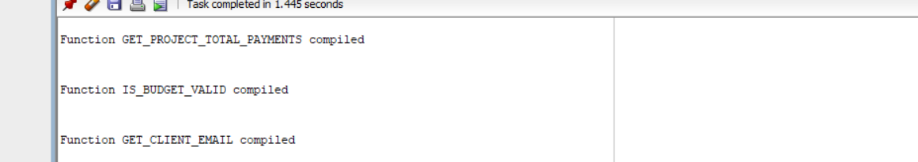

PACKAGE SPECIFICATION

This defines the functions and procedures that other users can call.

Codes:

CREATE OR REPLACE PACKAGE project_mgmt_pkg AS

-- Add a new project
PROCEDURE add_project(
p_title IN VARCHAR2,
p_type IN VARCHAR2,
p_start_date IN DATE,
p_end_date IN DATE,
p_budget IN NUMBER,
p_status IN VARCHAR2,
p_client_id IN NUMBER
);

-- Update a project's budget
PROCEDURE update_project_budget(
p_project_id IN NUMBER,
p_new_budget IN NUMBER
);

-- Get the rank of a project based on budget (using window function)
FUNCTION get_project_rank(
p_project_id IN NUMBER
) RETURN NUMBER;

-- Get total payments of project (wrapper for your existing function)
FUNCTION total_payments(
p_project_id IN NUMBER
) RETURN NUMBER;

END project_mgmt_pkg;
/

PACKAGE BODY (IMPLEMENTATION)

This contains the actual SQL code for each procedure and function.
Codes:

CREATE OR REPLACE PACKAGE BODY project_mgmt_pkg AS

-- 1. Add new project
PROCEDURE add_project(
p_title IN VARCHAR2,
p_type IN VARCHAR2,
p_start_date IN DATE,
p_end_date IN DATE,
p_budget IN NUMBER,
p_status IN VARCHAR2,
p_client_id IN NUMBER
) AS
BEGIN
INSERT INTO Projects (title, project_type, start_date, end_date, budget, status, client_id)
VALUES (p_title, p_type, p_start_date, p_end_date, p_budget, p_status, p_client_id);

COMMIT;
EXCEPTION
WHEN OTHERS THEN
DBMS_OUTPUT.PUT_LINE('Error adding project: ' || SQLERRM);
END add_project;

-- 2. Update project budget
PROCEDURE update_project_budget(
p_project_id IN NUMBER,
p_new_budget IN NUMBER
) AS
BEGIN
UPDATE Projects
SET budget = p_new_budget
WHERE project_id = p_project_id;

IF SQL%ROWCOUNT = 0 THEN
DBMS_OUTPUT.PUT_LINE('No project found with that ID.');
END IF;

COMMIT;
EXCEPTION
WHEN OTHERS THEN
DBMS_OUTPUT.PUT_LINE('Error updating budget: ' || SQLERRM);
END update_project_budget;

-- 3. Get project rank by budget (RANK window function)
FUNCTION get_project_rank(
p_project_id IN NUMBER
) RETURN NUMBER AS
v_rank NUMBER;
BEGIN
SELECT rnk INTO v_rank
FROM (
SELECT project_id,
RANK() OVER (ORDER BY budget DESC) AS rnk
FROM Projects
)
WHERE project_id = p_project_id;

RETURN v_rank;

EXCEPTION
WHEN NO_DATA_FOUND THEN
RETURN NULL;
WHEN OTHERS THEN
DBMS_OUTPUT.PUT_LINE('Error getting rank: ' || SQLERRM);
RETURN NULL;
END get_project_rank;

-- 4. Wrapper around your existing total payments function
FUNCTION total_payments(
p_project_id IN NUMBER
) RETURN NUMBER
AS
BEGIN
RETURN get_project_total_payments(p_project_id);
END total_payments;

END project_mgmt_pkg;
/



WINDOW FUNCTIONS

- ROW_NUMBER – Unique numbering per project
Numbers projects from highest budget to lowest.

Code

SELECT
project_id,
title,
budget,
ROW_NUMBER() OVER (ORDER BY budget DESC) AS row_num
FROM Projects;

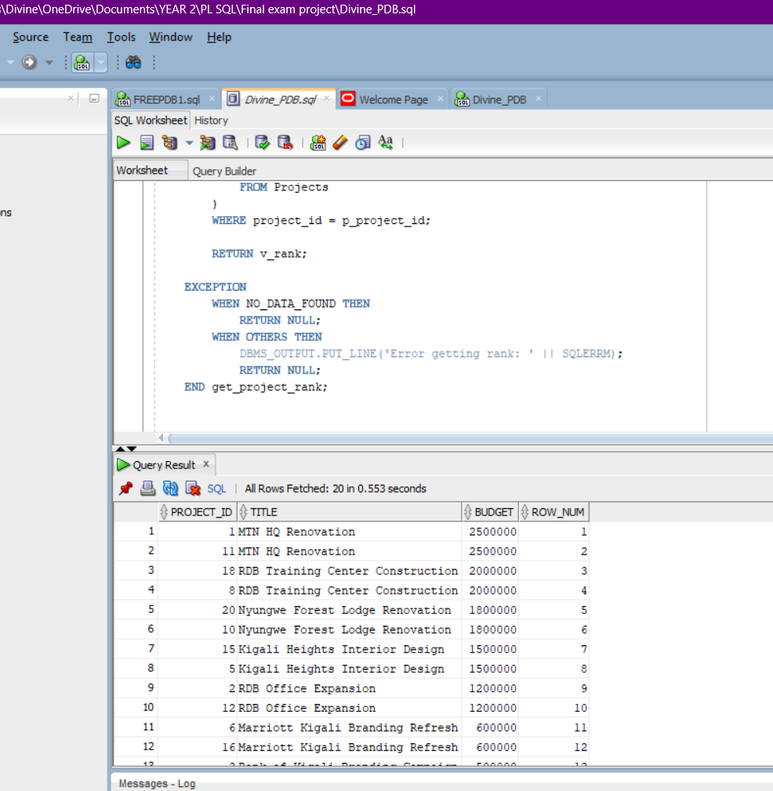

- RANK – Ranking projects by budget (with gaps)
Ranks projects by budget; equal budgets share rank, gaps may appear.

Code:

SELECT
project_id,
title,
budget,
RANK() OVER (ORDER BY budget DESC) AS rank_no
FROM Projects;

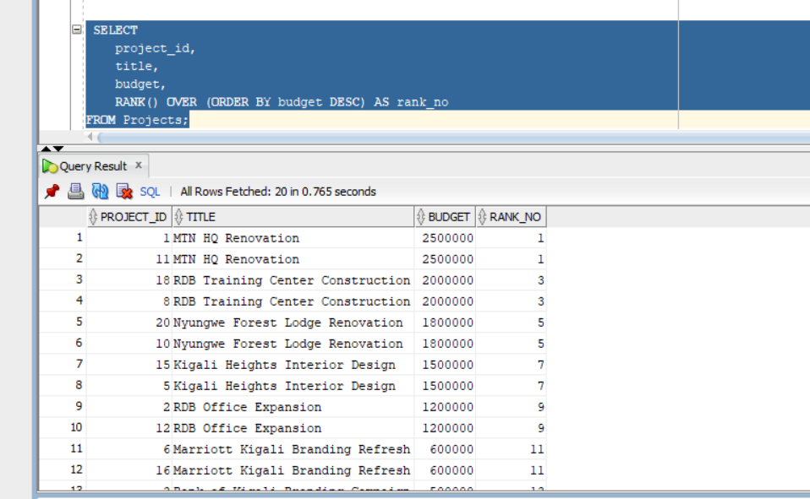

- DENSE_RANK – Ranking projects (no gaps)

Code:
SELECT
project_id,
title,
budget,
DENSE_RANK() OVER (ORDER BY budget DESC) AS dense_rank_no
FROM Projects;
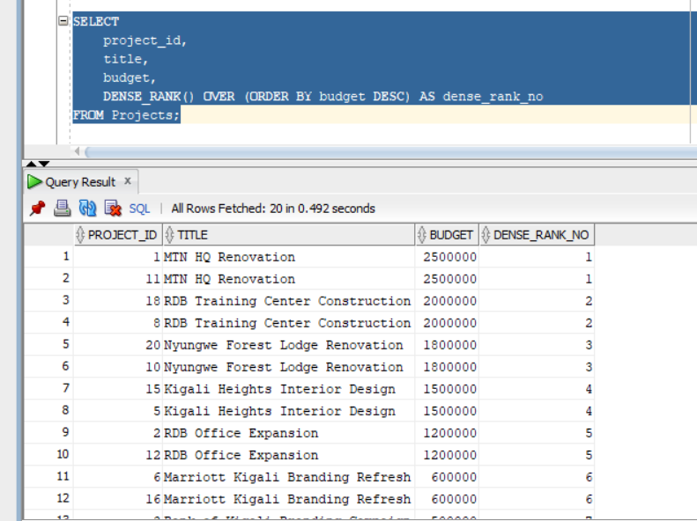

- PARTITION BY – Ranking projects per client

Ranks projects within each client, not across all clients.

Code:

SELECT
client_id,
project_id,
title,
budget,
RANK() OVER (PARTITION BY client_id ORDER BY budget DESC) AS client_rank
FROM Projects;

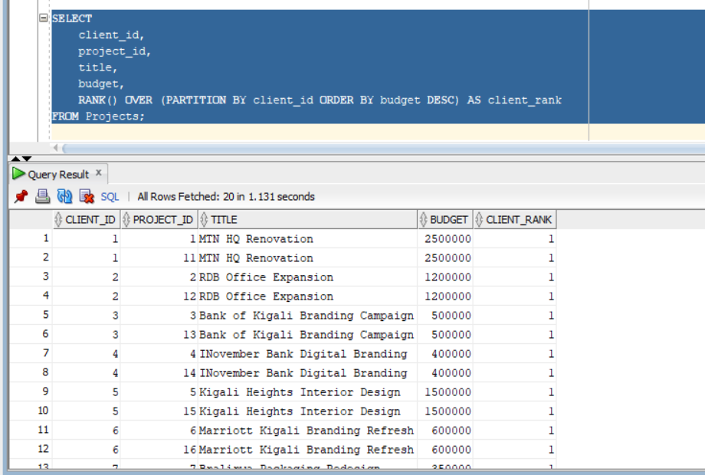

- LAG – Compare current project budget to previous one

Shows the previous project’s budget for comparison.

Code:

SELECT
project_id,
title,
budget,
LAG(budget, 1) OVER (ORDER BY budget) AS previous_budget
FROM Projects;

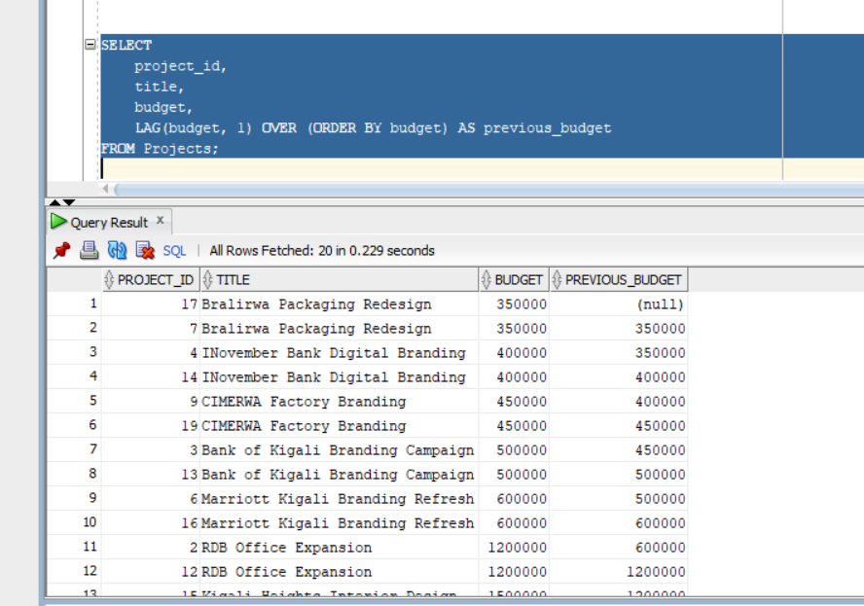

- LEAD – Compare with next project budget

Shows the next project’s budget.

Code:

SELECT
project_id,
title,
budget,
LEAD(budget, 1) OVER (ORDER BY budget) AS next_budget
FROM Projects;

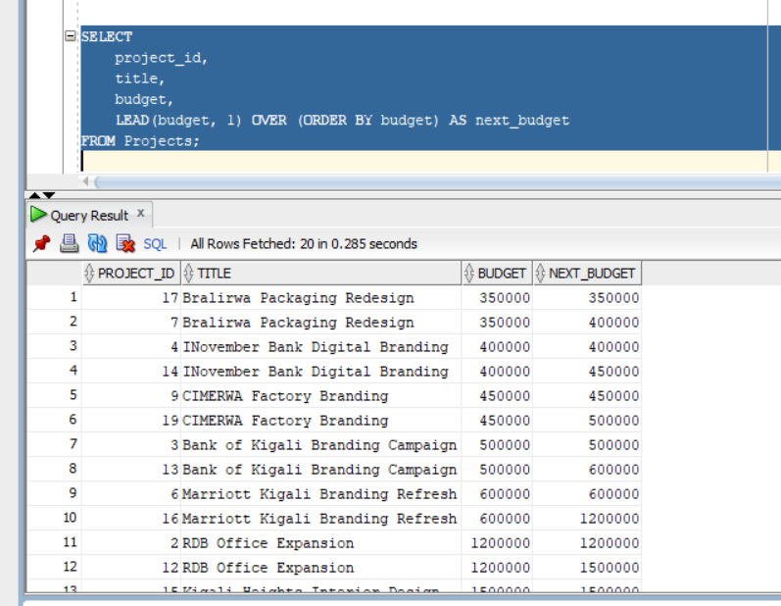

Aggregate with OVER – Average project budget

Shows the average budget next to each project.
Code:
SELECT
project_id,
title,
budget,
AVG(budget) OVER () AS avg_budget
FROM Projects;

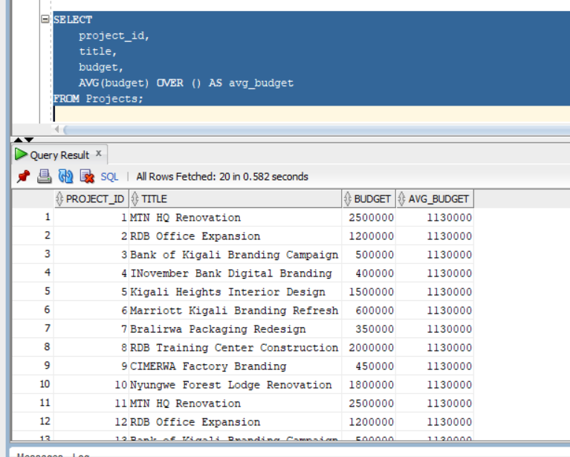

Aggregate + PARTITION – Total sales per project
Shows total payments per project without grouping rows away.
Code:
SELECT
sale_id,
project_id,
amount,
SUM(amount) OVER (PARTITION BY project_id) AS total_project_sales
FROM Sales;
